**Linux Basic Commands**

1. pwd (Present Working Directory)

Whenever you feel lost in the filesystem, call the “pwd” command to know where you are.



**Pwd will print the current path.**

1. **ls**

list all the files and directories



**Note:** In Linux you have multiple options with commands like ls -l for long listing, ls -a for showing the hidden files in the directory and much more.

1. **cd (Change Directory)**

Once you have a folder, you can move into it using the cd command. cd means **c**hange **d**irectory. You invoke it specifying a folder to move into. You can specify a folder name, or an entire path.

1. **cd .. goto the one step back from the current**
2. **cd goto the home directory from where you are.**

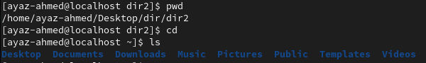

From the snipe my current location is dir2 but when I used the cd command single it will move to the home directory.

1. mkdir (Make Directory) In Linux we call the folder a directory.

You can create the direcoty(Folder) using mkdir command.

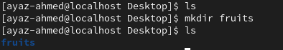

1. mkdir apple banana (for creating multiple directories using single command.)

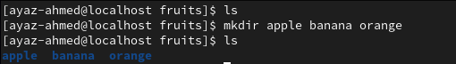

1. mkdir -p (for created nested directory means folder in folder)

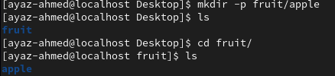

1. touch (will create the empty text file like notepad file)



1. touch file{1..10}.txt (this command will create a 10 txt file in one go)

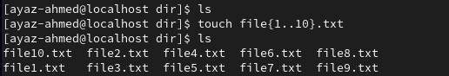

Note: this trick also works for directory (folders)

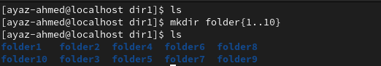

1. cat (its printout the content of file on the screen)

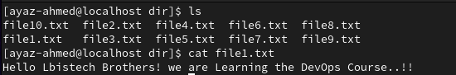

1. cat >(This command is also used for concatenation means combine two file content into a third txt file)

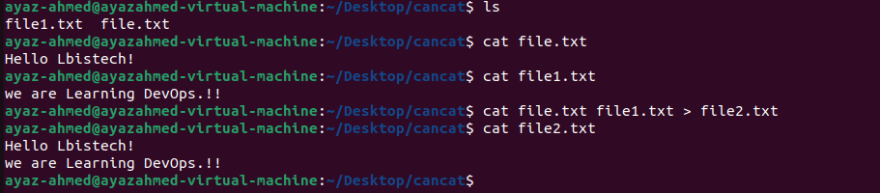

From this snip I have two files file.txt and file1.txt I have merge the content into a file2.txt by using the “cat > “command.

1. cat (You can print the content of multiple files)

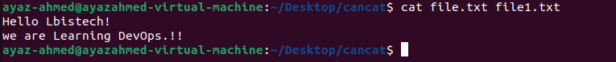

1. cat >> (this is used for append the content of file).

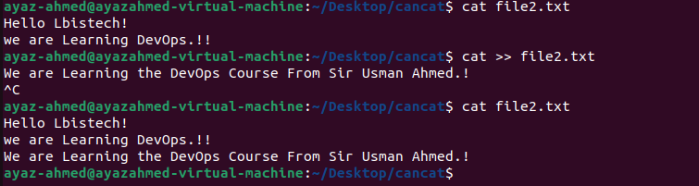

Note: The Difference Between > and >> operator from the ss you can see below.

* By Using > operator with cat command.

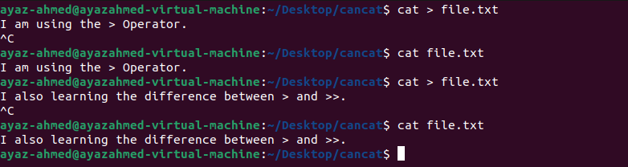

* By using >> Operator with cat command.

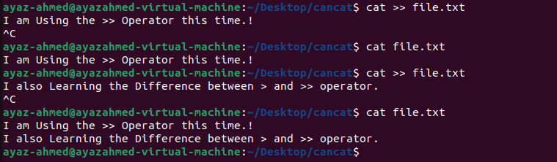

1. clear (to clean the screen for the fresh command).
2. cp (copy the file or directory from one position to another.)

* Case1: simple copy the “file2.txt” text file into “dir2” directory.

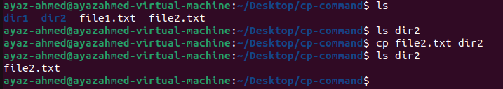

* Case2: copy the entire directory to another directory. We use -r option for directory.
* 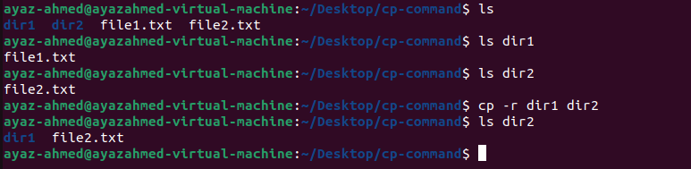Case3: From the current Location copy all the directory1 files to another directory.

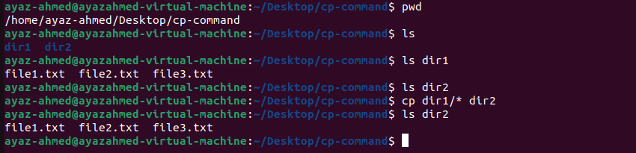

* Case4: If we have files and directory in particular location and we want to copy for example only directory not files.

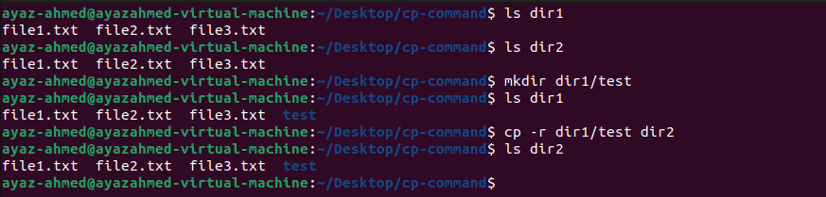

* Case5: if you are in different folder and want to copy the text file which is in previous locations folder.

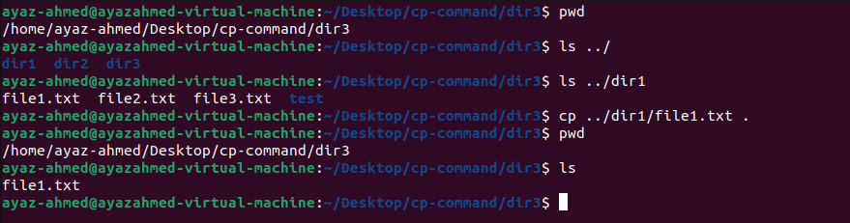

* Case6: copy that one file into the different directory(folder) not in the current.

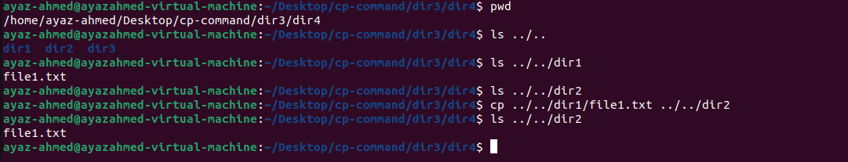

* Case7: if your file is in Desktop and your location is far away from Desktop.

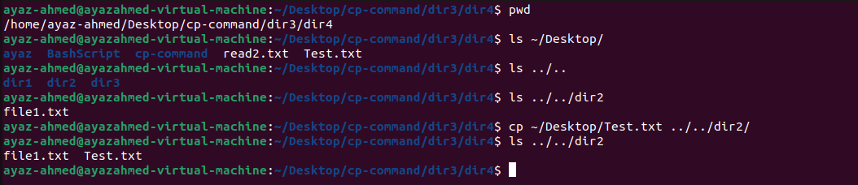

1. man (for manual means if you want to see the documentation of any command in Linux you can get help from man, whenever you don’t know about the command and its usage you have to use the command “man command-name”)
2. tldr (this is the extra command for learning purpose you will find the best documentation of commands like man command but the presentation is better then man command, sorry man.

Note:to install in your system just 1-“sudo apt install tldr”, 2-“tldr -u”, for update the package

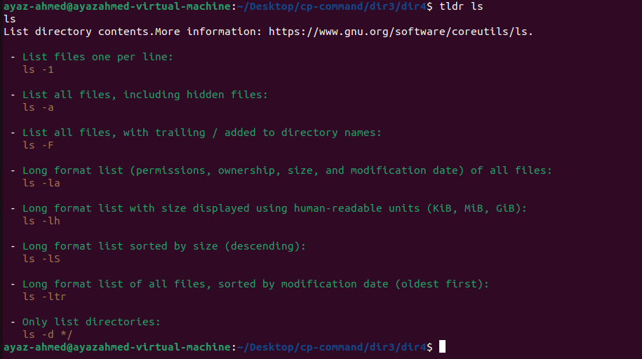

1. mv (Cute & Past also used for Rename the file.)

From this SS First we see the content into the dir1 and dir2 then we move the file from dir1 to dir2

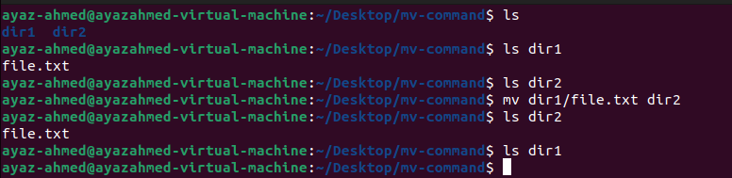

* This Command is also used for rename the text file:

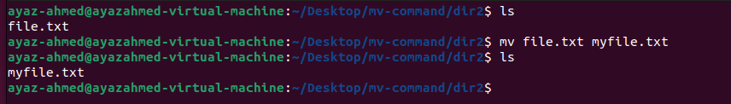

* You can also rename the directory.

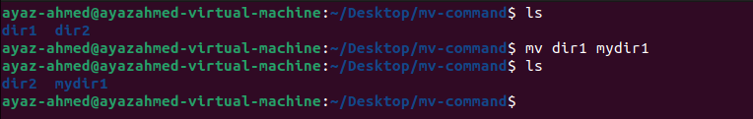

1. rm (Delete the file or directory and rm short for remove) below is the complete documentation with example.

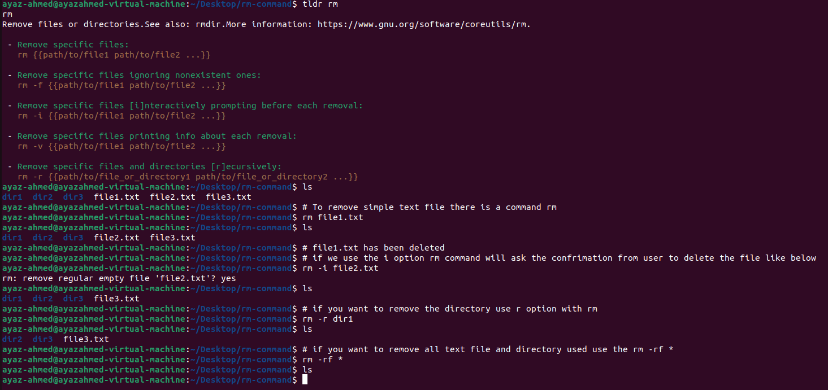

1. Extra Command tree (first have to install through sudo apt install tree, this fill show all your file like a tree structure.

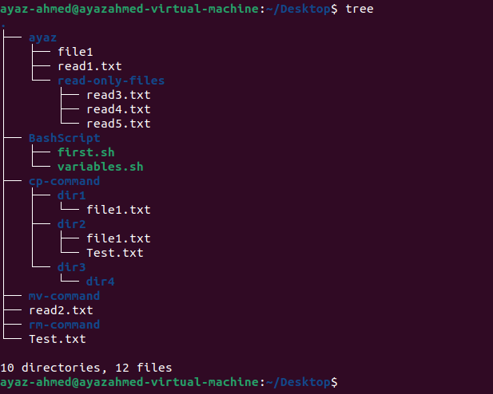

1. Sudo su – ( Switch from Normal user to sudo user if you have the privileges)

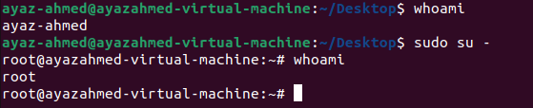

1. adduser user-name (add the new user, here is the example of adding the new user and switching from one user to another)

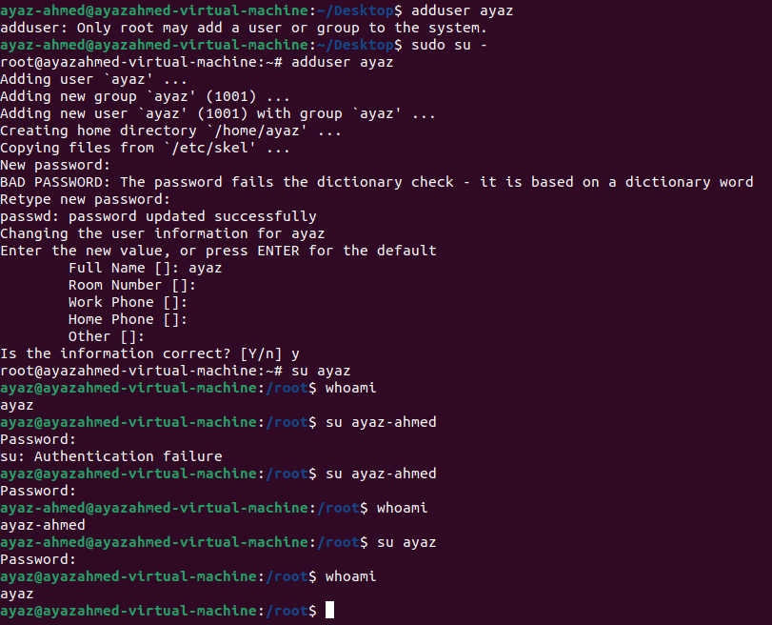

1. deluser user-name (Must use the sudo before command.)

**File Permission:**

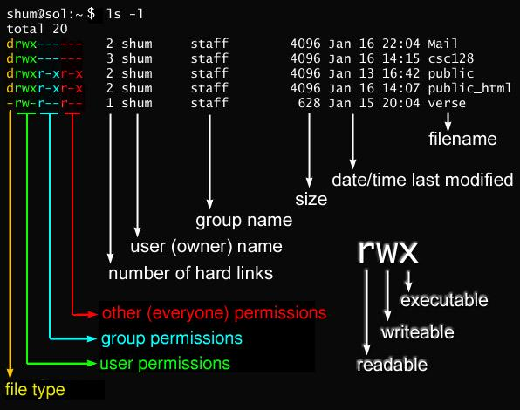

Must remember the code of each permission.

Read = 4

Write = 2

Execute = 1

Sum of total number is 7 which means that the user has the full rights to do anything.

Above the ss explains the every file permission is divided with three kind of users [User permissions like ayaz, ahmed or any other individual user, Group means all members of that one group and other means remaining all.]

Example: if I set 777 permission to any file means everyone has the full rights.

Command for File/Directory permission

1. chmod sumofnumber file-directory-name

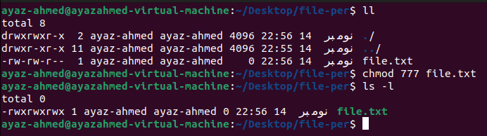

Example2: with no any rights to a text file:

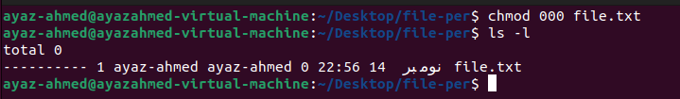

Directory permission:

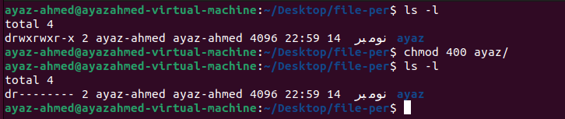

These is a slight difference between chmod and chmod -R here is chmod without R

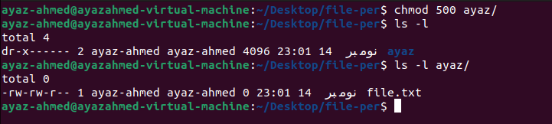

With chmod -R, have noticed the difference? Actually -R is applying the same permission to the files which are in directory.

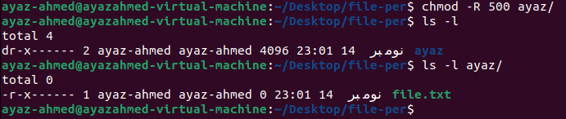

**Add the User in sudo group.**

Command: **sudo usermod -aG group-name user-name**.

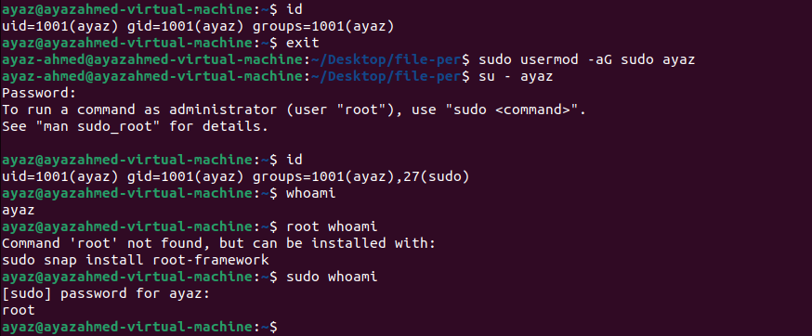

**How to add the user into the sudoers file.?**

Remember that sudoers file is placed in /etc/sudoers so, add you username under the root.

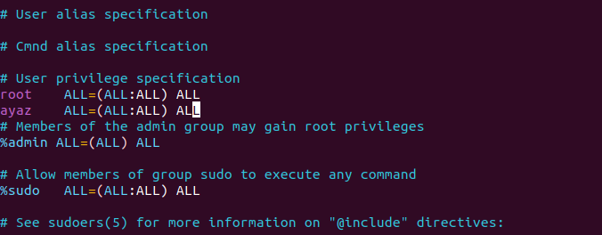

**Package Manager: apt commands:**

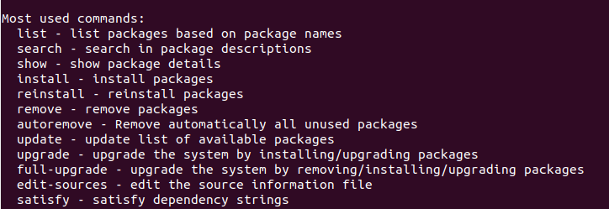

**SystemCTL Commands:**

1. systemctl status apache2 to see the status
2. systemctl start apache2 to start the apache2 service
3. systemctl stop apache2 to stop
4. systemctl enable apache2 will up the apache service when ever our server restart

**Installation of mysql-server and Its commands.**

Command: sudo apt install mysql-server

1. mysql to access the mysql server
2. show databases to see all the databases
3. show tables to see all the tables.
4. Select * from user will fetch all the data of user

Command which make sure the copy your system txt-data into vm-machine

* Sudo apt install open-vm-tools-desktop

**Commands for Cron Job in Linux**

1. **Crontab -l to see any cron job in the system**
2. **Crontab -e to edit the cron job and add something in that which you want to schedule.**
3. **Tail -f /var/log/syslog --for holding the screen for checking live logs.**

**AWK Tool**

**to search the file or content in Linux either in column-wise or row-wise or in any wany you want.**

**Very help in complex search like a greb command but grab have the limited feature to search anything.**

**For example, we have a file called data.txt**

**Content is:**

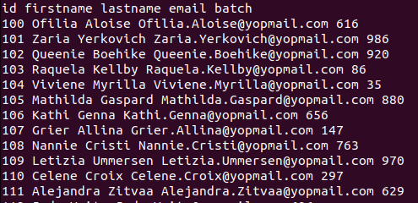

1. **awk ‘{print $0}’ data.txt -------------------------------------------------- To fatch all the data**
2. **awk ‘{print $1, $2, $3}’ data.txt ------------------------------------------ To fatch particular column.**
3. **awk ‘/Ale/ {print $0}’ data.txt -------------------------------------------- search the row-wise ‘Ale’**

* **NR Option for row number so if you want to search the by adding the row.**

1. **awk ‘{print NR, $0}’ data.txt**
2. **awk ‘NR==5 {print NR, $0}’ data.txt --- will print the row number 5**
3. **awk ‘NR==5 {print $0} ‘ data.txt ---- will print only the 5th row not with number.**
4. **awk ‘NR==2,NR==10 {print $0}’ data.txt – will print in range from 2 to 10 rows.**

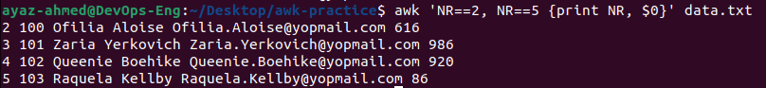

1. **awk ‘/Ofilia|Requela/ {print NR, $0}’ data.txt**



1. **awk -F, ‘{print $0} ’ data2.csv ---if you have csv file just use the F flag with comma mean we are separating the data with , so that we have to use ,.**
2. **awk ‘$NF>= 500 {print $0}’ data.txt --NF is used for last comlumn**

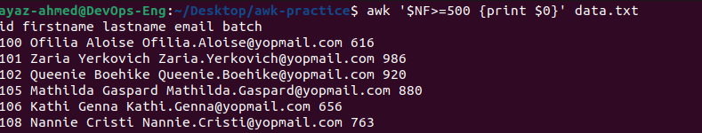

**Here NF search the batch column which is greater then or equal to 500**

**Use the AWK Command for fetching the systemctl status result only**



**AWK for Filtering the system logs.**

